* If user chooses option 2 to display the inventory items (note, so far no item is added in the inventory), following is displayed:

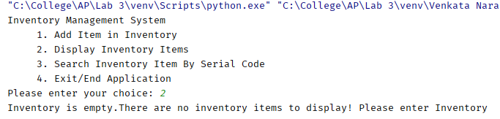

* Without adding any item in the inventory, if user chooses option 3 to search an item by its serial code.

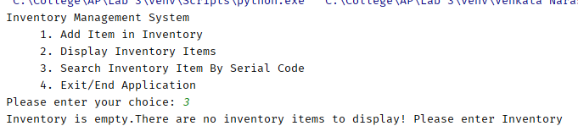

* If user chooses an option that is NOT valid option, any numeric or non-numeric value that is not in the list of 1, 2, 3 and 4,

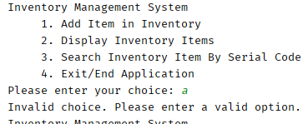

* if user chooses option 1, to add an item, When first item is added to the inventory

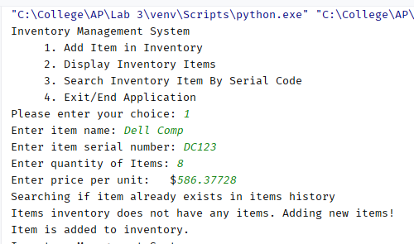

* A new item is added to the inventory of items.

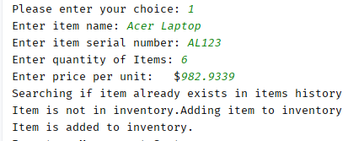

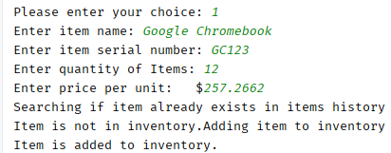

* Displaying the report of inventory items is option 2 and it displays

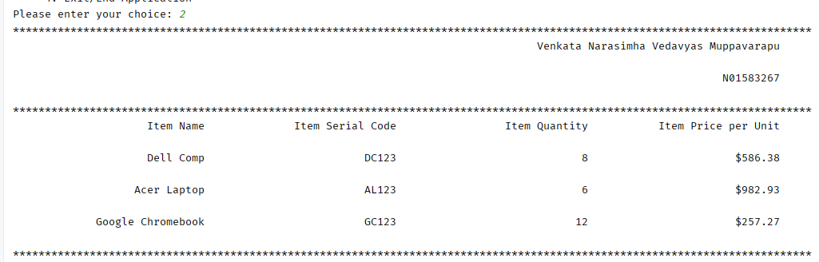

* If user chooses option 3 to search an item from the inventory based on the serial code

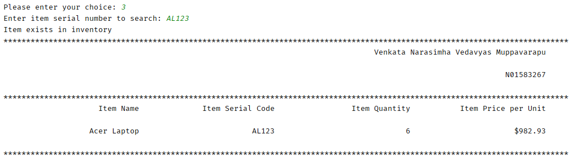

* If user chooses to search an item based on the Serial Code and Serial code does not exist in the item inventory records

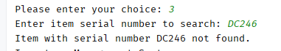

* Displaying the updated Quantity (price does not change):

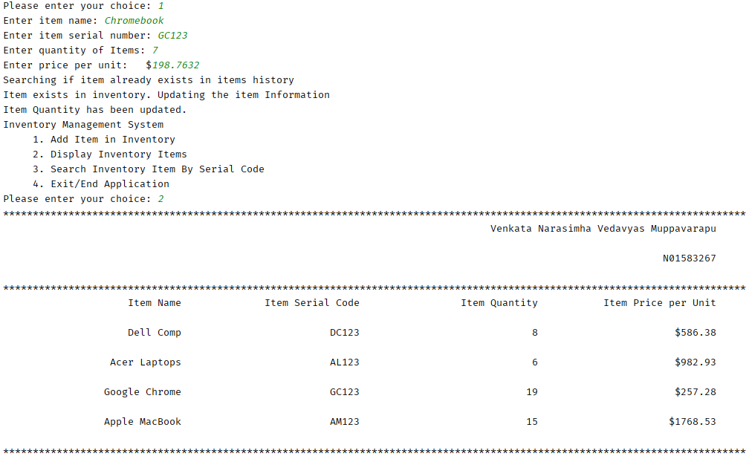

* Now if an item having same Serial Code added with higher item price than that is stored in the inventory, then new higher price is updated in the inventory, along with the new updated total items quantity in stock.

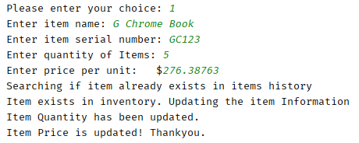

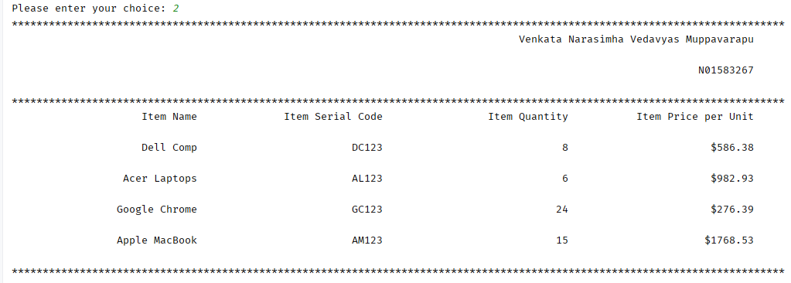

* If user chooses option 3 to search an item in the inventory, and the item Serial Code does not exist

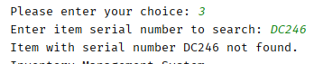

* When user chooses option 4, application ends (as shown above), after stating the fact that “Ending application …..”

